b



**<<PROJECT NAME>>**

**Software Design Specification**

– Hanoi, Summer 2024 –

**Record of changeS**

| **Date** | **A* M, D** | **In charge** | **Change Description** |
| --- | --- | --- | --- |
|  |  |  |  |
|  |  |  |  |
|  |  |  |  |
|  |  |  |  |
|  |  |  |  |
|  |  |  |  |
|  |  |  |  |
|  |  |  |  |
|  |  |  |  |
|  |  |  |  |
|  |  |  |  |
|  |  |  |  |
|  |  |  |  |

*A - Added M - Modified D - Deleted

**Table of Contents**

I. Overview 4

1. Code Packages 4

2. Database Design 4

a. Database Schema 4

b. Table Description 4

II. Code Designs 5

1. <Feature/Function Name1> 5

a. Class Diagram 5

b. Class Specifications 5

c. Sequence Diagram(s) 5

d. Database queries 6

2. <Feature/Function Name2> 6

# I. Overview

## 1. Code Packages

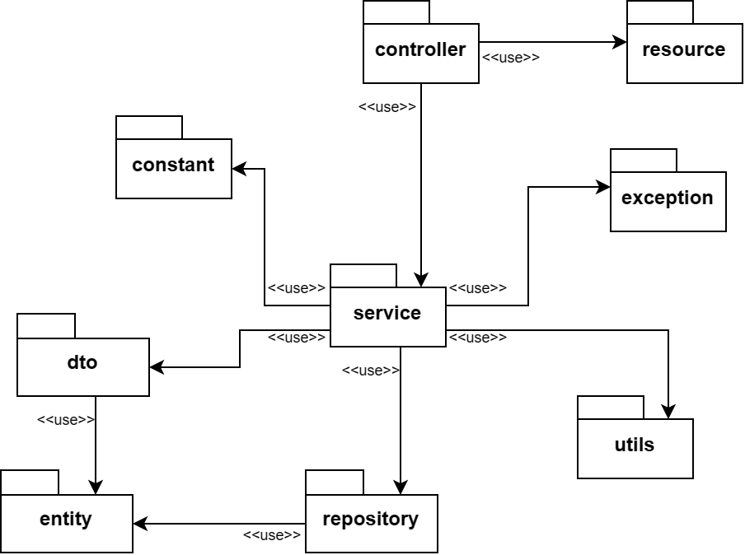

***Package descriptions***

| **No** | **Package** | **Description** |
| --- | --- | --- |
| 01 | controller | Handle the user requests, return responses and control the flow of the application |
| 02 | resource | Contains all files used for view (public assets, HTML, CSS, …) |
| 03 | constant | The constants used for the application |
| 04 | exception | Define custom exceptions and handle exceptions |
| 05 | service | Business logic, data handling, connect *repository* with *controller* |
| 06 | repository | Data Access Layer package, used to connect and access to databases |
| 07 | entity | Data Access Object package, used to map Java Objects with tables in databases |
| 08 | dto | Data Transfer Object package, used to simplify *entity* and to communicate in upper layer of the application |
| 09 | utils | Utility package, contains utility files |

## 2. Database Design

### a. Database Schema

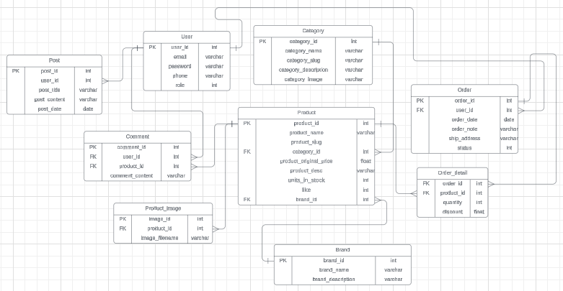

### b. Table Description

### 

| **No** | **Table** | **Description** |
| --- | --- | --- |
| 01 | User | Contains information about the users of the application, such as user ID, username, password, email, and other personal details. |
| 02 | Category | Stores categories for products, including category ID, name, image and description. |
| 03 | Order | Represents customer orders, containing order ID, user ID, order date, total amount, and order status |
| 04 | Order_detail | Details of each order, including order ID, product ID, quantity. |
| 05 | Brand | Contains information about product brands, including brand ID, name, and description. |
| 06 | Product | Stores details about products, such as product ID, name, description, price, stock quantity, category ID, and brand ID. |
| 07 | Product_image | Stores images for products, including product image ID, product ID and image file name. |
| 08 | Comment | Contains user comments or reviews for products, including comment ID, user ID, product ID, content |
| 09 | Post | Stores posts, such as blog posts or news articles, including post ID, title, content, user ID, and publication date. |

# II. Code Designs

## 1. <Feature/Function Name1>

*[Provide the detailed design for the function <Feature/Function Name1>. It include Class Diagram, Class Specifications, and Sequence Diagram(s)]*

### a. Class Diagram

*[This part presents the class diagram for the relevant feature]*

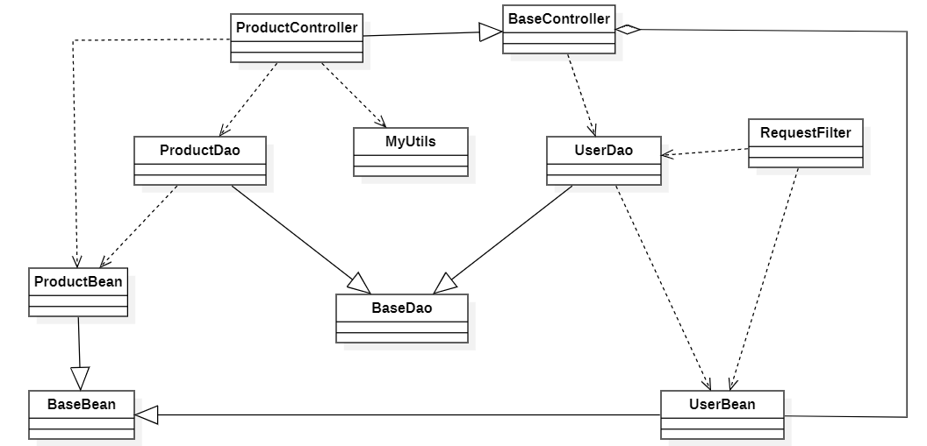

### b. Class Specifications

*[Provide the description for each class and the methods in each class, following the table format as below]*

#### XYZ Class

*[Provide the detailed description for the class methods]*

| **No** | **Method** | **Description** |
| --- | --- | --- |
| *01* | *<method name>* | *<Description of the method, including the inputs, outputs & internal method processing>* |
|  |  |  |

#### ABC Class

***Class Methods***

*[Provide the detailed description for the class methods]*

| **No** | **Method** | **Description** |
| --- | --- | --- |
| *01* | *<method name>* | *<Description of the method, including the inputs, outputs & internal method processing>* |
|  |  |  |

### c. Sequence Diagram(s)

*[Provide the sequence diagram(s) for the feature, see the sample below]*

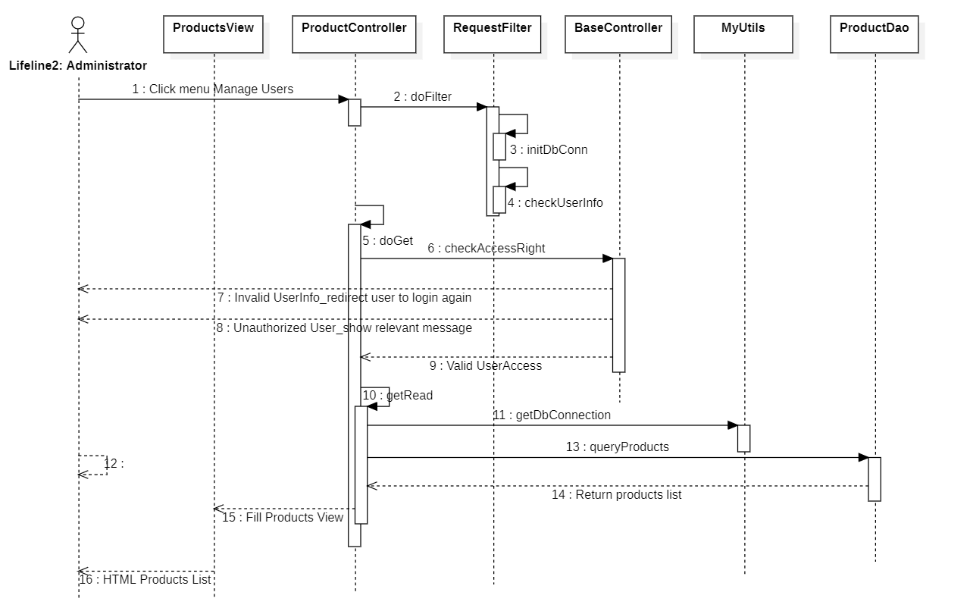

### d. Database Queries

*[Provide the detailed SQL (select, insert, update...) which are used in implementing the function/screen]*

## 2. <Feature/Function Name2>

…